***Step LM***

[1] "Wages" "Deciles"

[3] "Gini_market" "Corporate_ta"

[5] "Unempl_rate" "Trade"

[7] "arp_mid" "`Researchers_(1mill_Pop)"

[9] "mrp_all" "Family"

[11] "Net_len_wi" "`gro%pop`"

[13] "instdepth" "Secondary_ed"

[15] "Gov_debt" "ins_effic"

[17] "Savings_percapit" "Deficit"

[19] "Social_prot" "Soc_kind"

[21] "employ_rate" "Tertiary_ed"

[23] "TOT" "property_tx"

[25] "GDP_pc"

***Relaimpo*** (ordenado por importancia)

Social_prot Secondary_ed Savings_percapit Gov_ex Soc_kind

0.105 0.083 0.073 0.063 0.061

Wages employ_rate GDP_pc TOT Corporate_ta

0.053 0.047 0.043 0.042 0.040

Tertiary_ed Health_exp Deficit property_tx Unempl_rate

0.034 0.028 0.027 0.024 0.022

regqua Gov_debt Net_len_wi instdepth ins_effic

0.020 0.018 0.017 0.017 0.014

HICP

0.010

***Relaimpo2***

Social_prot_ex_pen insaccess arp_mid

0.143 0.066 0.061

Trade Savings % GDP Researchers_(1mill_Pop)\r\r\n

0.060 0.059 0.056

R&D%GDP\r\r\n Net_mig ICT

0.049 0.046 0.042

Savings_percapit Family ind_tx

0.042 0.038 0.032

ruleoflaw voice prod&imp_tx

0.029 0.029 0.021

Soc_payable mrp_all Education_exp

0.020 0.020 0.012

gro%pop Deficit ins_effic

0.009 0.004 0.004

**Realimpo final altos**

Social_prot_ex_pen Secondary_ed arp_mid

0.097 0.061 0.060

Social_prot Savings % GDP Researchers_(1mill_Pop)\r\r\n

0.059 0.051 0.051

Trade insaccess R&D%GDP\r\r\n

0.049 0.047 0.042

Gov_ex Savings_percapit Family

0.039 0.038 0.037

ICT ind_tx Soc_kind

0.034 0.034 0.032

Net_mig TOT Corporate_ta

0.032 0.027 0.027

employ_rate GDP_pc Wages

0.025 0.025 0.018

**Realimpo bajos**

Social_prot_ex_pen Secondary_ed arp_mid

0.097 0.061 0.060

Social_prot Savings % GDP Researchers_(1mill_Pop)\r\r\n

0.059 0.051 0.051

Trade insaccess R&D%GDP\r\r\n

0.049 0.047 0.042

Gov_ex Savings_percapit Family

0.039 0.038 0.037

ICT ind_tx Soc_kind

0.034 0.034 0.032

Net_mig TOT Corporate_ta

0.032 0.027 0.027

employ_rate GDP_pc Wages

0.025 0.025 0.018

*CARET*

Maximum search iterations: 10

Restart after 5 iterations without improvement (0.4 restarts on average)

Internal performance values: RMSE, Rsquared

Subset selection driven to minimize internal RMSE

External performance values: RMSE, Rsquared, MAE

Best iteration chose by minimizing external RMSE

External resampling method: Cross-Validated (10 fold, repeated 3 times)

During resampling:

* the top 5 selected variables (out of a possible 46):

GDP_pc (53.3%), Unemp_tra (50%), Gov_ex (46.7%), Health_exp (43.3%), ind_tx (43.3%)

* on average, 13.5 variables were selected (min = 11, max = 18)

In the final search using the entire training set:

* 15 features selected at iteration 9 including:

property_tx, Net_mig, Gini_market, Education_exp, ind_tx ...

* external performance at this iteration is

RMSE Rsquared MAE

0.01537 0.93770 0.01149

> print(sa_obj$optVariables)

[1] "property_tx" "Net_mig" "Gini_market" "Education_exp" "ind_tx"

[6] "TOT" "Secondary_ed" "td_male" "Soc_payable" "mrp_all"

[11] "goveff" "ruleoflaw" "instdepth" "R&D%GDP\r\r\n" "Savings_percapit"

***library(randomForest)***

***library(DALEX)***

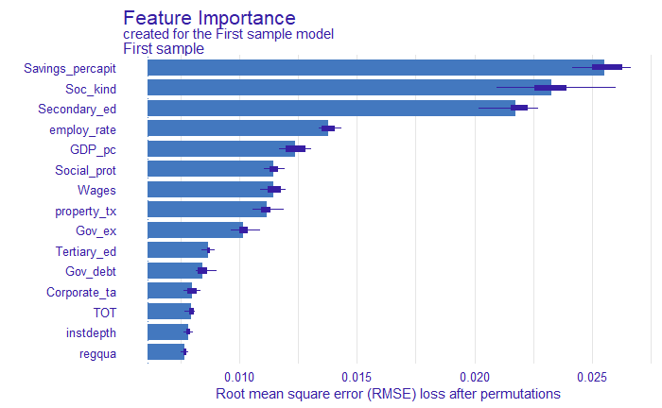

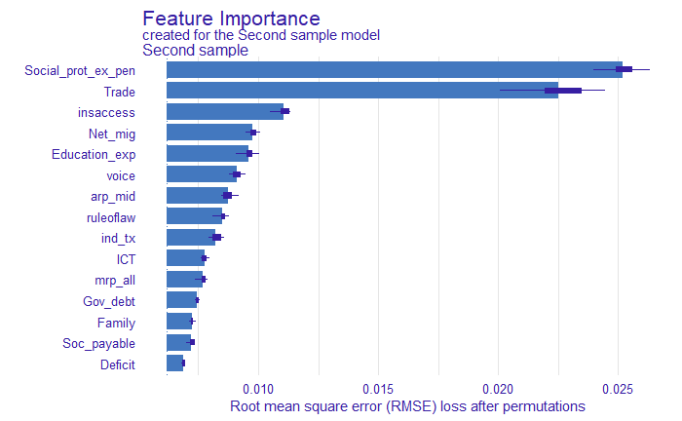

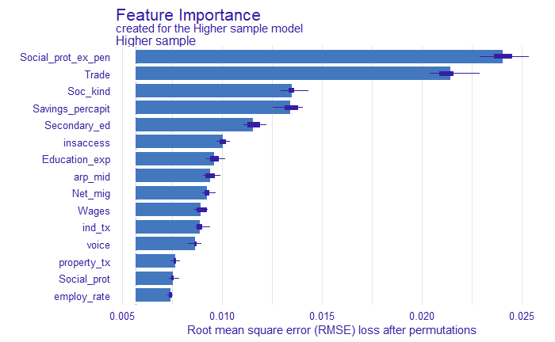

**BORUTA**

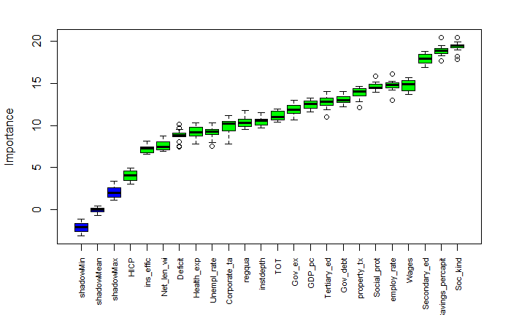

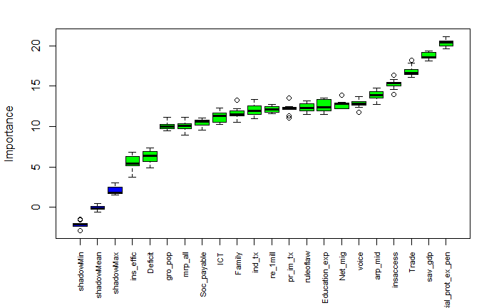

***RFE CARET***

The top 20 variables (out of 46):

gro_pop, Gini_market, employ_rate, Social_prot, TOT, Deciles, arp_mid, Trade, mrp_all, ind_tx, ins_effic, Tertiary_ed, re_1mill, Secondary_ed, GDP_pc, instdepth, pr_im_tx, Social_prot_ex_pen, Corporate_ta, Family